

**RESTAURANT MANAGEMENT**

***Members:***

**NGUYEN HUU TRONG - CE140372**

**DO THANH TAI - CE140136**

**NGUYEN MINH QUANG - CE140508**

**TRUONG THANH TOAN - CE140640**

**Lecturer**

**LUONG HOANG HUONG**



Restaurant Manager PRJ311 Desktop Java Applications 1 | P a g e



**TABLE OF CONTENT**

**I. Problem definition 3**

**II. User requirement 4**

**III. Schedule and role 6**

**IV. Database: 8**

**V. Interface 13**

**VI. Backup data 16**

**VII. Check List 17**



Restaurant Manager PRJ311 Desktop Java Applications 2 | P a g e



**I. Problem definition**

Today, the population is increasing and the lives of people are increasing, so the demand for shopping, tourism, especially for eating and drinking is also increasing.

With that demand, more and more shops service food and drinks, but it also brings a lot of store management issues because actually managing a store is a very difficult job and complex. According to the current survey, there are many stores still managed in the traditional way of writing on paper. It is very inconvenient and carries a lot of risks because of low security, time-consuming and labor-intensive, the number of customers at the store is often crowded, the customers are often retail customers or go in small groups. Therefore, the store model is often difficult to control. Understanding that, we decided to create an app so we could trust store management and make it more convenient and faster for users with multiple functions for the same reason, price.

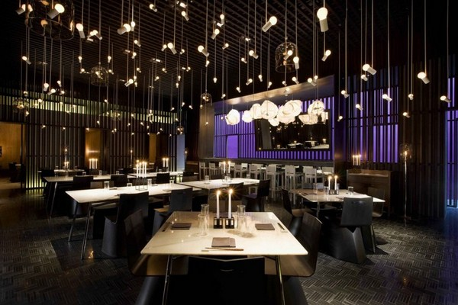

*Figure 1.Restaurant*

Restaurant Manager PRJ311 Desktop Java Applications 3 | P a g e



**II. User requirement**

**1. Form**

**\*Input**

-

-

Product management: user input product’s name, type, price, size, brand name.

Customer management: user input your name’s customer, phone number, email.

* Bill management: user input name product, amount of product, customer name, price, employee name.

-

-

Employee management: employee name, phone number, email.

Account management: manager account, employee account

**\*Output**

* Product management: Display all product in warehouse, search. Add and update (check status).
* Customer management: Display information all of customer. Add and update (check status).
* Bill management: Print bill (bill about: name products, amount of product, cost of product, name customer, total money, seller’s name, date and time sell product) and back up bill into database. Add and show (check status).

-

-

-

-

List of account: account name. Add and update (check status).

List of employee: name, phone number, email. Add and update (check status).

Help: how to use program. Add and update (check status).

About: Information of group. Add and update (check status).

**\*Overview**

-

-

User input information’s product when store and name product sell.

Print and back up bill after have sold.



Restaurant Manager PRJ311 Desktop Java Applications 4 | P a g e



**2. Hardware and software**

**\*Hardware**

|  |  |  |  |  |  |  |
| --- | --- | --- | --- | --- | --- | --- |
|  | **Hardware requirement** |  |  |  | **Hardware requirement** |  |
|  | **(minimal configuration)** |  |  |  | **(recommended configuration)** |  |
|  |  |  |  |  |  |  |

* CPU: 500 MHz processor
* RAM: 2GB RAM
* HDD: 500MB of free disk space
* CPU: 4GHZ Dual Core or 3GHZ processor
* RAM: 4GB RAM
* HDD: 1GB of free disk space

**\*Software**

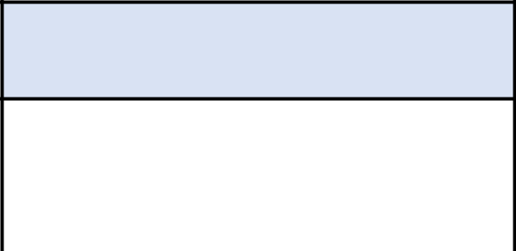

**Software requirement**

* Window 7 or higher
* JRE 1.7 or higher



Restaurant Manager PRJ311 Desktop Java Applications 5 | P a g e



**III. Schedule and role**

* 1. **Role**

|  |  |  |  |
| --- | --- | --- | --- |
| **No** | **Name of member** | **Role** | **Responsibility** |
|  |  |  |  |
| 1 | TrongNH | Leader | Assignment of tasks |
|  |  |  |  |
| 2 | ToanTT,QuangNM | Analyst | Define problem, input, output, process |
|  |  |  |  |
| 3 | TrongNH,TaiDT | Design | Design interface |
|  |  |  |  |
| 4 | TrongNH,TaiDT,ToanTT,QuangNM | Coder | Program all functions for project |
|  |  |  |  |
| 5 | TrongNH,TaiDT,ToanTT,QuangNM | Tester | Testing all functions for project |
|  |  |  |  |
| 6 | TrongNH,TaiDT,ToanTT,QuangNM | Maintenaner | Check and backup data |
|  |  |  |  |



Restaurant Manager PRJ311 Desktop Java Applications 6 | P a g e



**2. Schedule**

|  |  |  |  |  |
| --- | --- | --- | --- | --- |
|  |  |  | **Estimated number** |  |
| **No.** | **Document Name** | **Date** | **of hours** | **Member names** |
|  |  |  | **completed** |  |
|  |  |  |  |  |
| 1 | Problem definition | 16/02/2020 | 3 | TrongNH,TaiDT,ToanTT,QuangNM |
|  |  |  |  |  |
| 2 | User requirement | 18/02/2020 | 3 | TrongNH,TaiDT |
|  |  |  |  |  |
| 3 | Analysis | 23/03/2020 | 24 | ToanTT,QuangNM |
|  |  |  |  |  |
| 4 | Making document | 24/03/2020 | 5 | TrongNH,TaiDT,ToanTT,QuangNM |
|  |  |  |  |  |
| 5 | Design database diagram | 23/03/2020 | 24 | TrongNH,TaiDT |
|  |  |  |  |  |
| 6 | Coding demo | 21/03/2020 | 24 | TrongNH,TaiDT,ToanTT,QuangNM |
|  |  |  |  |  |
| 7 | Testing demo | 22/03/2020 | 24 | TrongNH,TaiDT,ToanTT,QuangNM |
|  |  |  |  |  |
| 8 | Design Powerpoint | 25/03/2020 | 5 | QuangNM |
|  |  |  |  |  |
| 9 | Design Interface | 24/03/2020 | 12 | TrongNH,TaiDT,ToanTT,QuangNM |
|  |  |  |  |  |
| 10 | Edit code | 20/03/2020 | 12 | TrongNH,TaiDT,ToanTT,QuangNM |
|  |  |  |  |  |
| 11 | Check code | 21/03/2020 | 12 | TrongNH,TaiDT,ToanTT,QuangNM |
|  |  |  |  |  |
| 12 | Test-Fix error | 22/03/2020 | 12 | TrongNH,TaiDT,ToanTT,QuangNM |
|  |  |  |  |  |
| 13 | Complete code | 26/03/2020 | 3 | TrongNH,TaiDT,ToanTT,QuangNM |
|  |  |  |  |  |
| 14 | Testing final | 26/03/2020 | 3 | TrongNH,TaiDT,ToanTT,QuangNM |
|  |  |  |  |  |
| 15 | Check Document | 26/03/2020 | 3 | TrongNH,TaiDT,ToanTT,QuangNM |
|  |  |  |  |  |
| 16 | Complete Project | 27/03/2020 | 3 | TrongNH,TaiDT,ToanTT,QuangNM |
|  |  |  |  |  |



Restaurant Manager PRJ311 Desktop Java Applications 7 | P a g e

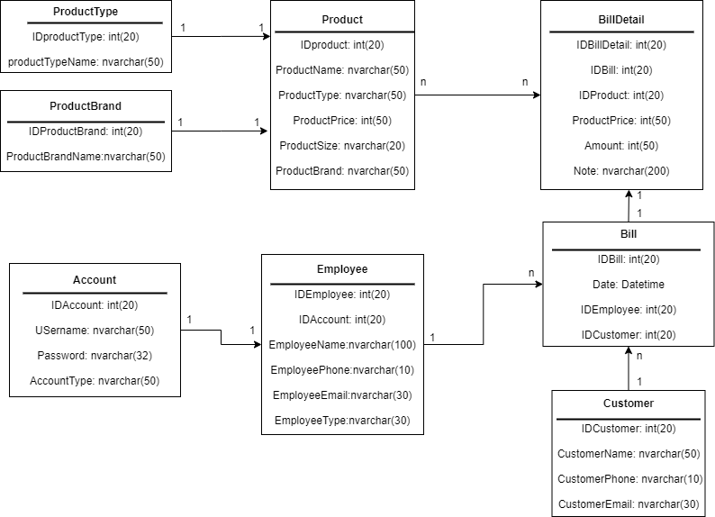

**IV. Database**

**1. Database diagram**

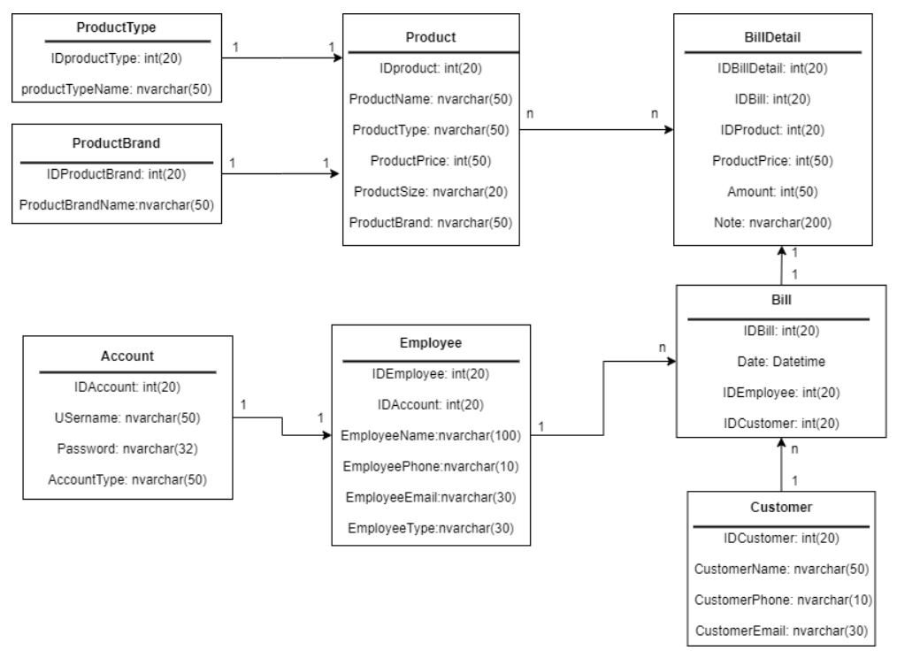

*Figure 2.* Restaurant management





Restaurant Manager PRJ311 Desktop Java Applications 8 | P a g e

**2. Table structure**

|  |  |  |  |
| --- | --- | --- | --- |
| **Table 1.** | **Product** |  |  |
|  |  |  |  |
| **Field Name** | **Data Type** | **Constraint** | **Description** |
| pid | int(20) | PRIMARY KEY | ID’s Username |
| pname | nvarchar(50) | NOT NULL | Name of product |
| ptype | nvarchar(50) | NOT NULL | Type of product |
| price | int(50) | NOT NULL | Price of product |
| size | nvarchar(10) | NOT NULL | Size of product |
| brand | nvarchar(20) | NOT NULL | Brand of product |

|  |  |  |  |
| --- | --- | --- | --- |
| **Table 2.** | **Employee** |  |  |
|  |  |  |  |
| **Field Name** | **Data Type** | **Constraint** | **Description** |
| eid | int(20) | PRIMARY KEY | ID’s employee |
| aid | int(20) | NOT NULL | ID’s account |
| ename | nvarchar(100) | NOT NULL | Name of employee |
| ephone | nvarchar(10) | NOT NULL | Phone number of employee |
| eemail | nvarchar(30) | NOT NULL | Email of employee |
| etype | nvarchar(30) | NOT NULL | Type of employee |

|  |  |  |  |
| --- | --- | --- | --- |
| **Table 3.** | **Account** |  |  |
|  |  |  |  |
| **Field Name** | **Data Type** | **Constraint** | **Description** |
| aid | int(20) | PRIMARY KEY | ID’s account |
| aname | nvarchar(50) | NOT NULL | Username |
| apass | nvarchar(32) | NOT NULL | Password |
| atype | nvarchar(30) | NOT NULL | Type of account |

|  |  |  |  |
| --- | --- | --- | --- |
| **Table 4.** | **Customer** |  |  |
|  |  |  |  |
| **Field Name** | **Data Type** | **Constraint** | **Description** |
| cid | int(20) | PRIMARY KEY | ID’s customer |
| cname | nvarchar(50) | NOT NULL | Name of customer |
| cphone | nvarchar(10) | NOT NULL | Phone of customer |
| cemail | nvarchar(30) | NOT NULL | Email of customer |

|  |  |  |  |
| --- | --- | --- | --- |
| **Table 5.** | **Bill** |  |  |
|  |  |  |  |
| **Field Name** | **Data Type** | **Constraint** | **Description** |
| bid | int(20) | PRIMARY KEY | ID’s bill |
| date | date time | NOT NULL | Date of bill |
| eid | int(20) | NOT NULL | ID’s employee |
| cid | int(20) | NOT NULL | ID’s customer |



Restaurant Manager PRJ311 Desktop Java Applications 9 | P a g e



|  |  |  |  |
| --- | --- | --- | --- |
| **Table 6.** | **Bill Detail** |  |  |
|  |  |  |  |
| **Field Name** | **Data Type** | **Constraint** | **Description** |
| bdid | int(20) | PRIMARY KEY | ID’s bill detail |
| bid | int(20) | NOT NULL | ID’s bill |
| pid | int(20) | NOT NULL | ID’s product |
| price | int(50) | NOT NULL | Price of product |
| amount | int(50) | NOT NULL | Amount |
| note | nvarchar(200) | NOT NULL | Note |



Restaurant Manager PRJ311 Desktop Java Applications 10 | P a g e

**3. Class diagram**

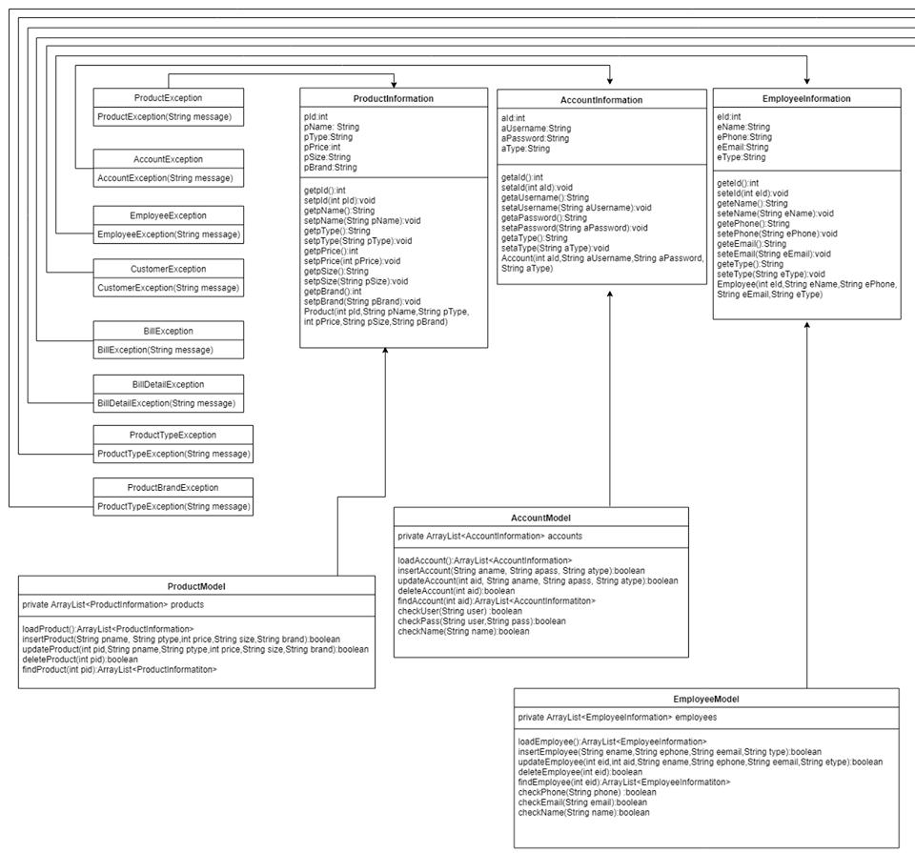

*Figure 3.* *Class diagram (1)*



Restaurant Manager PRJ311 Desktop Java Applications 11 | P a g e



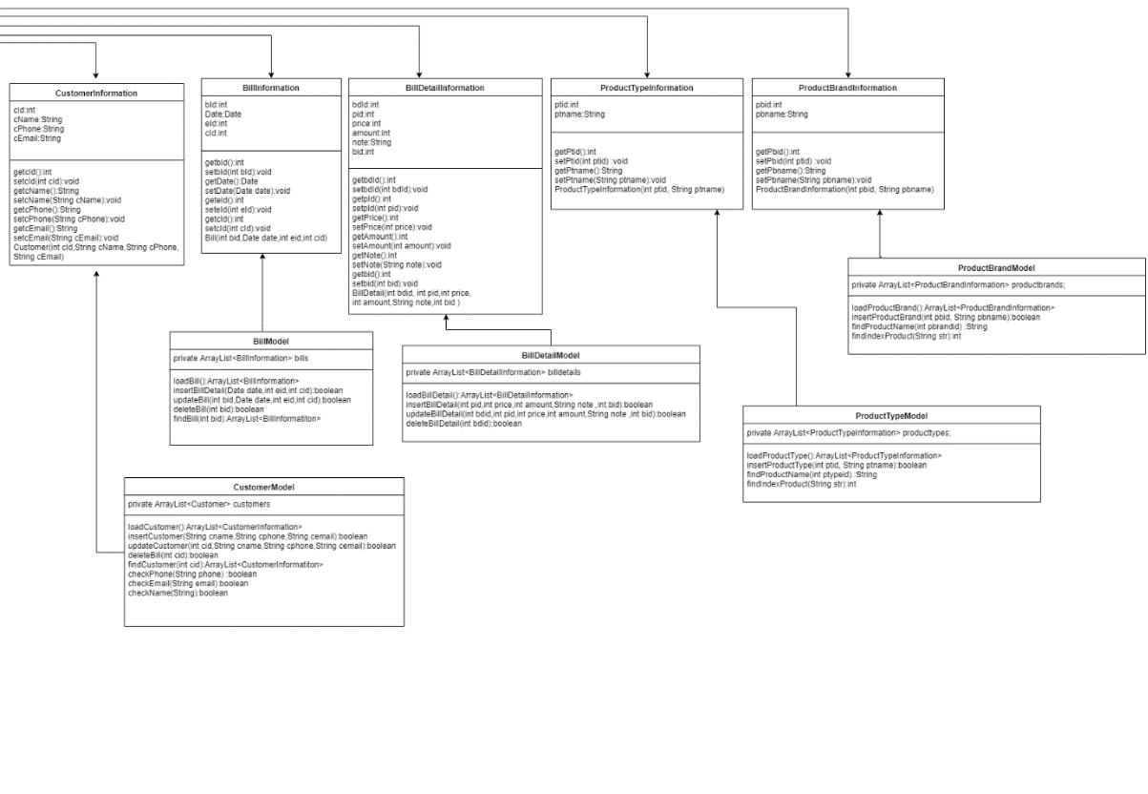

*Figure 4.* *Class diagram (2)*



Restaurant Manager PRJ311 Desktop Java Applications 12 | P a g e



**V. Interface**

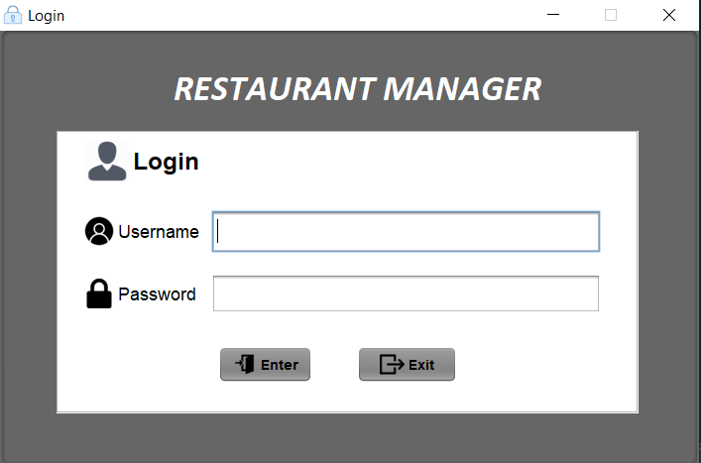

*Figure 5.* *Login Interface*

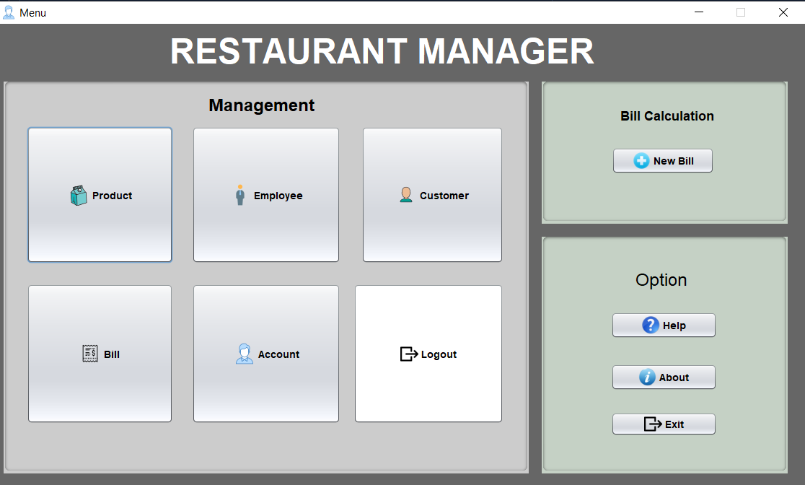

*Figure 6. Restaurant Menu*



Restaurant Manager PRJ311 Desktop Java Applications 13 | P a g e

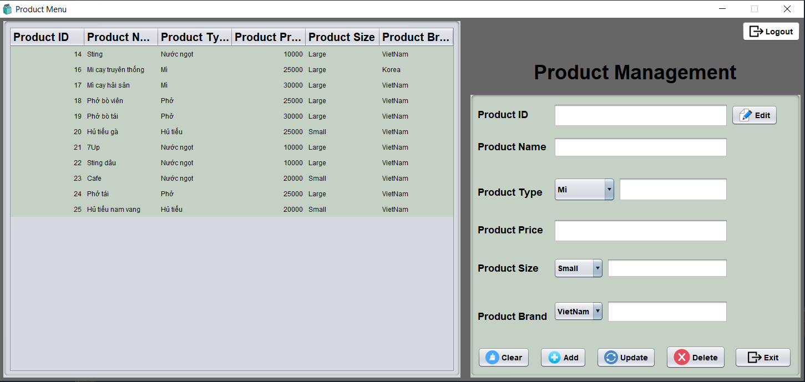

*Figure 7.* *Product Management*

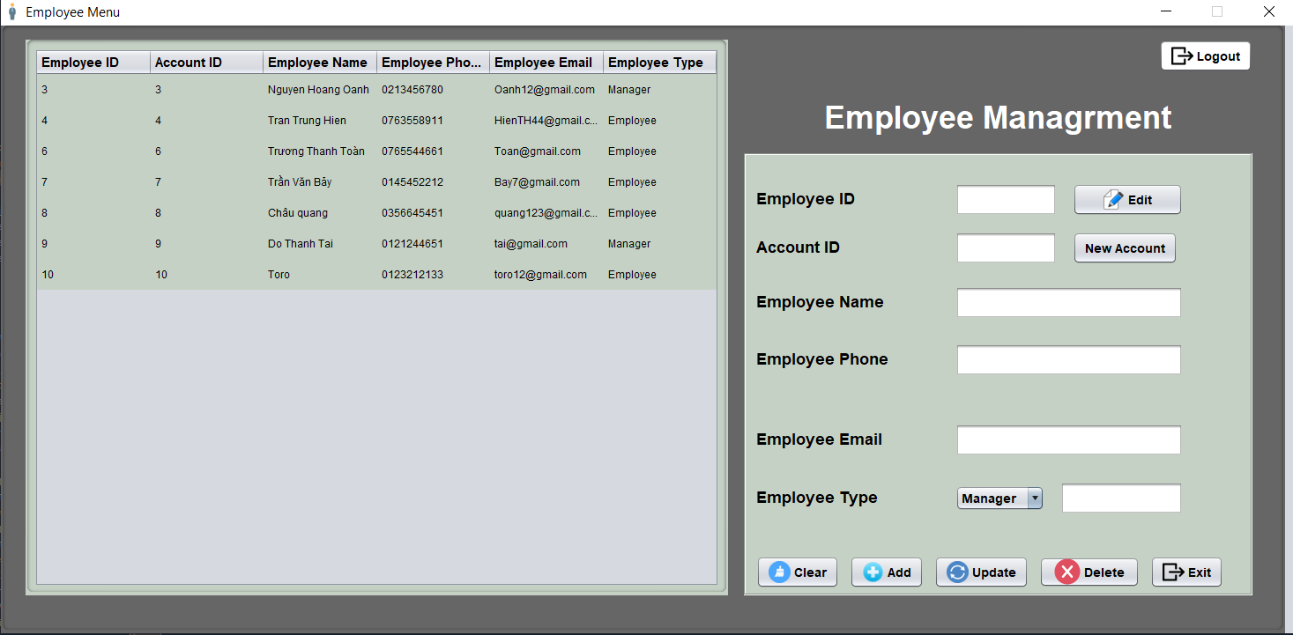

*Figure 8. Employee* *Management*

Restaurant Manager PRJ311 Desktop Java Applications 14 | P a g e

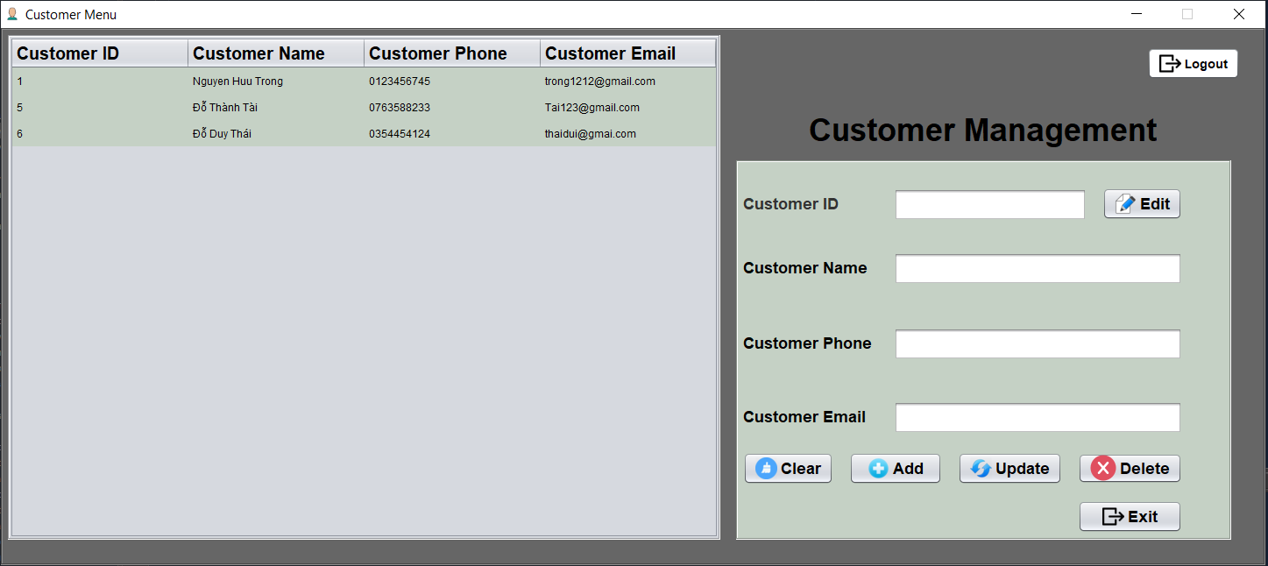

*Figure 9. Customer Management*

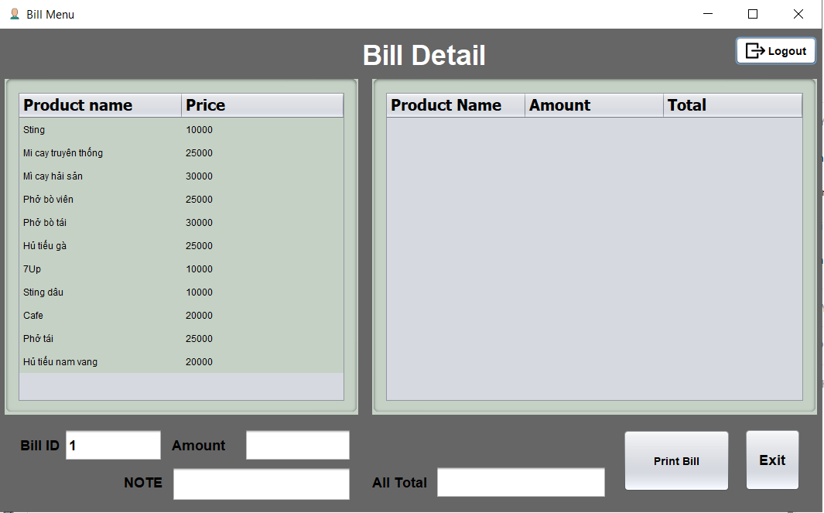

*Figure 10.* *Bill Detail*



Restaurant Manager PRJ311 Desktop Java Applications 15 | P a g e



**VI. Backup data**

Everyday, we always upload all data in Google Drive and send that our program to each member in group. By this way, we don’t worry that our program will be destroyed or lost and we are sure each member in group can be understand program.

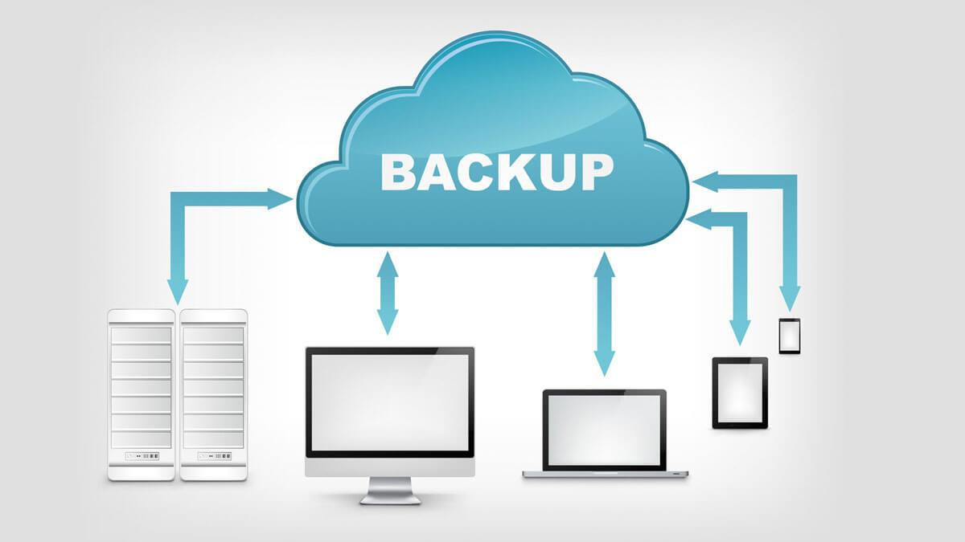

*Figure 11.* *Backup Data*



Restaurant Manager PRJ311 Desktop Java Applications 16 | P a g e



**VII. Check List:**

|  |  |  |  |  |  |  |  |  |  |  |  |  |  |  |  |  |  |  |  |  |  |  |  |  |  |
| --- | --- | --- | --- | --- | --- | --- | --- | --- | --- | --- | --- | --- | --- | --- | --- | --- | --- | --- | --- | --- | --- | --- | --- | --- | --- |
|  |  | |  |  |  |  |  |  |  |  | **Estimated** |  |  |  |  |  |  |  |  |  |  |  |  |  |  |
|  | **No.** | |  |  | **Document** |  |  | **Date** |  |  | **number** |  |  | **Complete** |  |  | **Real** |  |  | **Member names** |  |  | **Note** |  |  |
|  |  |  | **Name** |  |  |  |  | **of hours** |  |  | **time** |  |  | **time** |  |  |  |  |  |  |
|  | |  |  |  |  |  |  |  |  |  |  |  |  |  |  |  |  |  |  |  |  |
|  |  | |  |  |  |  |  |  |  |  | **completed** |  |  |  |  |  |  |  |  |  |  |  |  |  |  |
| 1 | | |  |  | Problem | | 24/03/2020 | |  | 3 | |  | 12:00 | |  | 3 | |  |  | TrongNH,TaiDT,ToanTT,QuangNM | |  | Complete | |  |
|  |  | definition | |  |  | 24/03/2020 | |  |  |  |  | |  |  |
|  |  | |  |  |  |  |  |  |  |  |  |  |  |  |  |  |  |  |  |
| 2 | | |  |  | User | | 24/03/2020 | |  | 3 | |  | 23:00 | |  | 3 | |  |  | TrongNH,TaiDT | |  | Complete | |  |
|  |  | requirement | |  |  | 24/03/2020 | |  |  |  |  |  |
|  |  | |  |  |  |  |  |  |  |  |  |  |  |  |  |  |  |  |  |  |  |
| 3 | | |  |  | Analysis | | 24/03/2020 | |  | 24 | |  | 12:00 | |  | 24 | |  |  | ToanTT,QuangNM | |  | Complete | |  |
|  |  |  |  | 24/03/2020 | |  |  |  |  |  |
|  |  | |  |  |  |  |  |  |  |  |  |  |  |  |  |  |  |  |  |  |  |  |  |
| 4 | | |  |  | Making | | 25/03/2020 | |  | 5 | |  | 20:00 | |  | 9 | |  |  | TrongNH,TaiDT,ToanTT,QuangNM | |  | Delay 4h | |  |
|  |  | document | |  |  | 25/03/2020 | |  |  |  |  | |  |  |
|  |  | |  |  |  |  |  |  |  |  |  |  |  |  |  |  |  |  |  |
| 5 | | |  |  | Design database | | 26/03/2020 | |  | 24 | |  | 23:00 | |  | 24 | |  |  | TrongNH,TaiDT | |  | Complete | |  |
|  |  | diagram | |  |  | 26/03/2020 | |  |  |  |  |  |
|  |  | |  |  |  |  |  |  |  |  |  |  |  |  |  |  |  |  |  |  |  |
| 6 | | |  |  | Coding demo | | 26/03/2020 | |  | 24 | |  | 23:00 | |  | 24 | |  |  | TrongNH,TaiDT | |  | Complete | |  |
|  |  |  |  | 26/03/2020 | |  |  |  |  |  |
|  |  | |  |  |  |  |  |  |  |  |  |  |  |  |  |  |  |  |  |  |  |  |  |
| 7 | | |  |  | Testing demo | | 26/03/2020 | |  | 24 | |  | 12:00 | |  | 24 | |  |  | TrongNH,TaiDT | |  | Complete | |  |
|  |  |  |  | 27/03/2020 | |  |  |  |  | |  |  |
|  |  | |  |  |  |  |  |  |  |  |  |  |  |  |  |  |  |  |  |  |  |
| 8 | | |  |  | Design | | 24/03/2020 | |  | 5 | |  | 20:00 | |  | 5 | |  |  | QuangNM | |  | Complete | |  |
|  |  | Powerpoint | |  |  | 24/03/2020 | |  |  |  |  |  |
|  |  | |  |  |  |  |  |  |  |  |  |  |  |  |  |  |  |  |  |  |  |
| 9 | | |  |  | Design | | 23/03/2020 | |  | 12 | |  | 23:00 | |  | 12 | |  |  | TrongNH,TaiDT,ToanTT,QuangNM | |  | Complete | |  |
|  |  | Interface | |  |  | 23/03/2020 | |  |  |  |  | |  |  |
|  |  | |  |  |  |  |  |  |  |  |  |  |  |  |  |  |  |  |  |
| 10 | | |  |  | Edit code | | 22/03/2020 | |  | 12 | |  | 12:00 | |  | 13 | |  |  | TrongNH,TaiDT,ToanTT,QuangNM | |  | Delay 1h | |  |
|  |  |  |  | 22/03/2020 | |  |  |  |  | |  |  |
|  |  | |  |  |  |  |  |  |  |  |  |  |  |  |  |  |  |  |  |  |  |
| 11 | | |  |  | Check code | | 23/03/2020 | |  | 12 | |  | 22:30 | |  | 10 | |  |  | TrongNH,TaiDT,ToanTT,QuangNM | |  | Complete | |  |
|  |  |  |  | 23/03/2020 | |  |  |  |  | |  |  |
|  |  | |  |  |  |  |  |  |  |  |  |  |  |  |  |  |  |  |  |  |  |
| 12 | | |  |  | Test-Fix error | | 24/03/2020 | |  | 12 | |  | 12:00 | |  | 15 | |  |  | TrongNH,TaiDT,ToanTT,QuangNM | |  | Delay 3h | |  |
|  |  |  |  | 24/03/2020 | |  |  |  |  | |  |  |
|  |  | |  |  |  |  |  |  |  |  |  |  |  |  |  |  |  |  |  |  |  |
| 13 | | |  |  | Complete code | | 26/03/2020 | |  | 3 | |  | 20:00 | |  | 4 | |  |  | TrongNH,TaiDT,ToanTT,QuangNM | |  | Delay 1h | |  |
|  |  |  |  | 26/03/2020 | |  |  |  |  | |  |  |
|  |  | |  |  |  |  |  |  |  |  |  |  |  |  |  |  |  |  |  |  |  |
| 14 | | |  |  | Testing final | | 27/03/2020 | |  | 3 | |  | 22:00 | |  |  |  |  |  | TrongNH,TaiDT,ToanTT,QuangNM | |  | Complete | |  |
|  |  |  |  | 27/03/2020 | |  |  |  |  |  |  | |  |  |
|  |  | |  |  |  |  |  |  |  |  |  |  |  |  |  |  |  |  |  |  |  |
|  |  | |  |  | Check | |  |  |  |  |  |  | 21:00 | |  |  |  |  |  | TrongNH,TaiDT,ToanTT,QuangNM | |  |  |  |  |
| 15 | | |  |  | 26/03/2020 | |  | 3 | |  | 26/03/2020 | |  | 3 | |  |  |  | Complete | |  |
|  |  | Document | |  |  |  |  |  |  | |  |  |
|  |  | |  |  |  |  |  |  |  |  |  |  |  |  |  |  |  |  |  |  |  |
|  |  | |  |  |  | |  |  |  |  |  |  |  | |  |  |  |  |  |  | |  |  |  |  |
| 16 | | |  |  | Complete | | 27/03/2020 | |  | 3 | |  | 23:00 | |  | 3 | |  |  | TrongNH,TaiDT,ToanTT,QuangNM | |  | Complete | |  |
|  |  | Project | |  |  | 27/03/2020 | |  |  |  |  | |  |  |
|  |  | |  |  |  |  |  |  |  |  |  |  |  |  |  |  |  |  |  |





Restaurant Manager PRJ311 Desktop Java Applications 17 | P a g e